Get school updates via your phone
Our school is now listed in the Schools NI app, which allows you to view school updates and receive messages via your phone or tablet. The app is available on both Apple and Android devices, and will give you access to our school news, calendar events and letters.

To install the app, open www.stbrigidspstirkane.com on your phone or tablet and click the ‘Download App’ button that appears at the top of the screen.

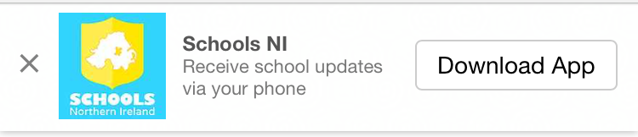
15th JANUARY 2020
Thank you / Go raibh maith agaibh to the108 parents who have already downloaded the school app and receive regular updates about events and information which has been added to the website. If you haven’t done so already, please take a few minutes to do this before the end of this week. These messages are FREE as part of the school’s website contract and are therefore the most economical and efficient method of communicating with parents. Thank you for your assistance in this matter. It is much appreciated. Go raibh maith agaibh.

