RANG 5/6 TRIP TO

HAZELWOOD IPS/BELFAST & W5

26.03.2018 (Monday)

9.05 – BUS DEPARTS ST BRIGID`S TIRKANE / BUNSCOIL NAOMH BRÍD
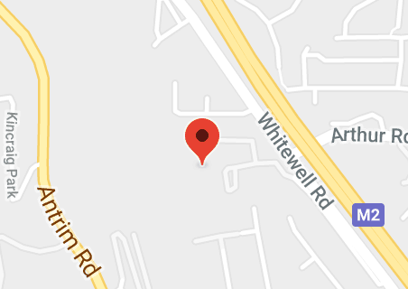

10.30 – ARRIVE AT HAZELWOOD IPS / BELFAST

MEET OUR PARTNER SCHOOL (P6 CLASS)

www.hazelwoodips.co.uk

12.00 – ARRIVE AT W5

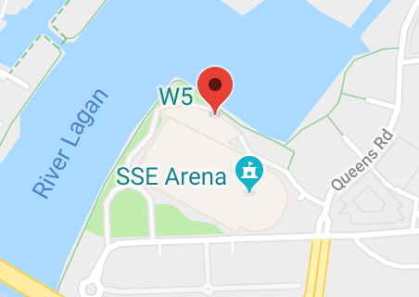
GROUP ACTIVITIES

Easter Alien Invaders

Augmented Reality Goes Wild

https://w5online.co.uk

W5 is an award winning Interactive Discovery Centre in Belfast, Northern Ireland. Located at the Odyssey Arena.

14.30 – BUS DEPARTS W5

15.45 – PUPILS RETURN TO SCHOOL FOR COLLECTION BY PARENTS

